**AC32005 – Human Computer Interaction**

**Travel Explorers**

**Interim Report**

**Kyle Harrison, Ross Strachan & Paul Cannings**

# Travel Explorer - Interim Report

## Description of the system

Travel Explorer being developed to allow individuals, particularly elderly (although not limited too), to share details of their travels in a safe and secure way, meet other likeminded individuals who wish to partake in the same trips or holidays, and the sharing of stories and other media between individuals that attended a trip or holiday.

During our initial focus group we wanted to test and refine our initial idea of a travel blog system and instead discovered a niche gap in the market between booking holidays/trips and researching holidays/trip for a system to allow users to meet and plan trips & holidays together. It became clear that elderly individuals wanted a more active travel lifestyle but often lacked other individuals who wanted to participate in the same activities.

## Focus Group

Initially testing our idea for a micro blog system through the use of a focus group was vital in determining if we should continue with our current idea or refactor it into something the participants preferred. A focus group allowed collection of some quantitative but mostly qualitative data through collecting multiple view points. During the focus group it also highlighted areas of consensus and conflict and helped identify key breakthroughs in determining our original idea wasn’t what the user group wanted.

At time during the focus group dominant participants appeared and directed the conversation with stories unrelated to our questions however we quickly established that the stories they were telling to the group was what interested the group members and we managed to redirect the conversation along this path to find out what parts of the individual stories they enjoyed the most and related it back to a system we could develop. The focus group encouraged contact between we the developers and the users of the system in a seamless and natural way producing information that would have been unobtainable from a survey.

**The Key points from this initial focus group were the following:**

* None of the participants ever felt they were too old to do something. Instead they only lacked others to share their interest. Our solution was to change from blogging about trips & holiday’s people have experienced in the past to creating new trips & holiday’s people could share with like minded individuals.
* Most participants held assumptions and to quote one participant she said, “I doubt I would be very good, I never travel”. Later during the focus group we found that the same individual did travel almost daily by bus and the other times she walked. This challenged our perception of how our user group viewed our project and promoted discussion on how we could change.

## Evaluation of current systems

We asked the users to suggest current systems they used in relation to our project and the problems associated with them. These websites were “Trip Advisor” and “Last minute”. Participants said they were difficult to use and pointed out that the issue was still present of finding a like minded individual who wanted to attend the same trip.

Evaluating these websites we discovered that they had large amounts of content on the screen at all times and often only provided a subset of the information users were interested in. They did not want to read long reviews to find a single bit of information and instead suggested a standard template style format that they could quickly brose for information such as local attractions, advice on the area, and safe and secure places to stay with local amenities such as transport within close proximity of their accommodation.

## Survey Methods: Surveys & Questionnaires

We decided to use an online service called “Survey Money” to create, distribute, and collect/analyse our results. We used Facebook to ask family and friends to complete the survey alongside using word of mouth to encourage others to take part. A survey allowed us to ask specific questions to a prospective large group of diverse individuals whilst using minimum resources. From this we could gather quantitative and qualitative data however the design of the survey was crucial in ensuring we received maximum Reponses by asking the general questions we wanted to asked followed by the more person. This ensured we would gather some of the data we needed in the event a user did not want to complete the personal questions such as age.

­

The response rate of the survey was not what we expected and this was always a risk due to participants not having an interest in completing a survey. We attempted to conduct the survey within the user centre but users were not interested in taking part during our allocate slot and during future slots time was not available to conduct a survey in addition to other allocated tasks

The survey was conducted to determine the types of devices our user group had available however the results we collected were from the 18-30 age range and the information from this demographic was greatly varied due to the range of technology younger generations have. We were hoping to prove survey participants over 50 were inclined to use older technology passed down from relatives or friends as the need to support older devices and software would impact the requirements of the system and future development. We opted to use online survey results to help aid our decision making as initially we had considered an Android or iPhone tablet application and from discussion with the focus group we quickly realised that not a lot of participants had a tablet device.

Using this large sample from the online survey results it enabled us to produce robust and reliable results using pre-existing questionnaires to provide empirical evidence that can be used for comparison between the data we collected, our findings from the focus group, and the data within the survey. The majority of information we gathered from the online statistics proved to be correct in reflecting the participants involved in the focus group as we provided our findings to the participants after asking the same questions to see if their answers matched along with if they agreed with the statements we made from the study.

This information gathered from the focus group helped us to decide the best type of device’s to support would be desktop and laptop computers through the use of a website. Supporting older technologies was also vital to insure access to the website and viewing of the content alongside creating a simplistic easy to use interface by adhering to w3 standards for accessibility.

## Functional and Non-functional requirements

We also produced a set of functional and non functional requirements from online research into usability and accessibility alongside web standards whilst also taking into account our own findings from surveys and focus groups. These requirements will continue to be updated and refined whilst we continue paper prototyping.

See appendix for Internet Survey Results

## Paper Prototype

We wanted to explore the differences between computer-based and paper-based prototypes to determine if participants confronted with both differ in their willingness to criticize a system and give suggestions for its improvement. Initially with a low fidelity paper prototype, we determined it may be difficult for participants with poor eye sight to view small text on a white background. We quickly reproduced the prototype with black text on a yellow background as a study suggested it retained information in human memory at a higher rate than other combinations. Though observation over several iterations of the prototype we could determine if the colour scheme of the website affects ease of use and memory recall in elderly participants. The high contrast may also increase readability in elderly participants and conforms to the W3 guidelines of avoid brightness differences less than 125 and colour differences less than 500. Quantitative and qualitative methods will also be applied to measure and to explain the users through process by using the “Think Aloud” method combined with observation and an individual interview with the participant after the testing is complete.

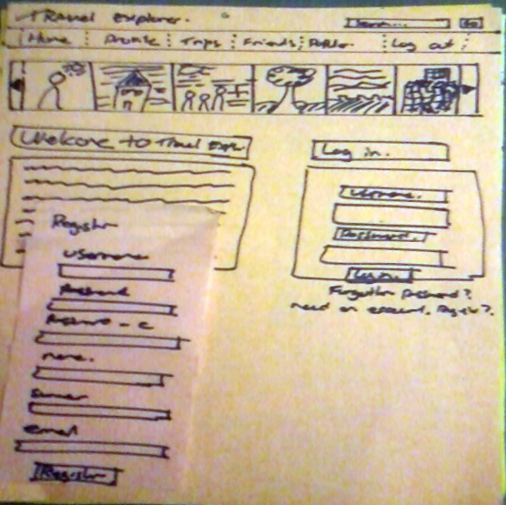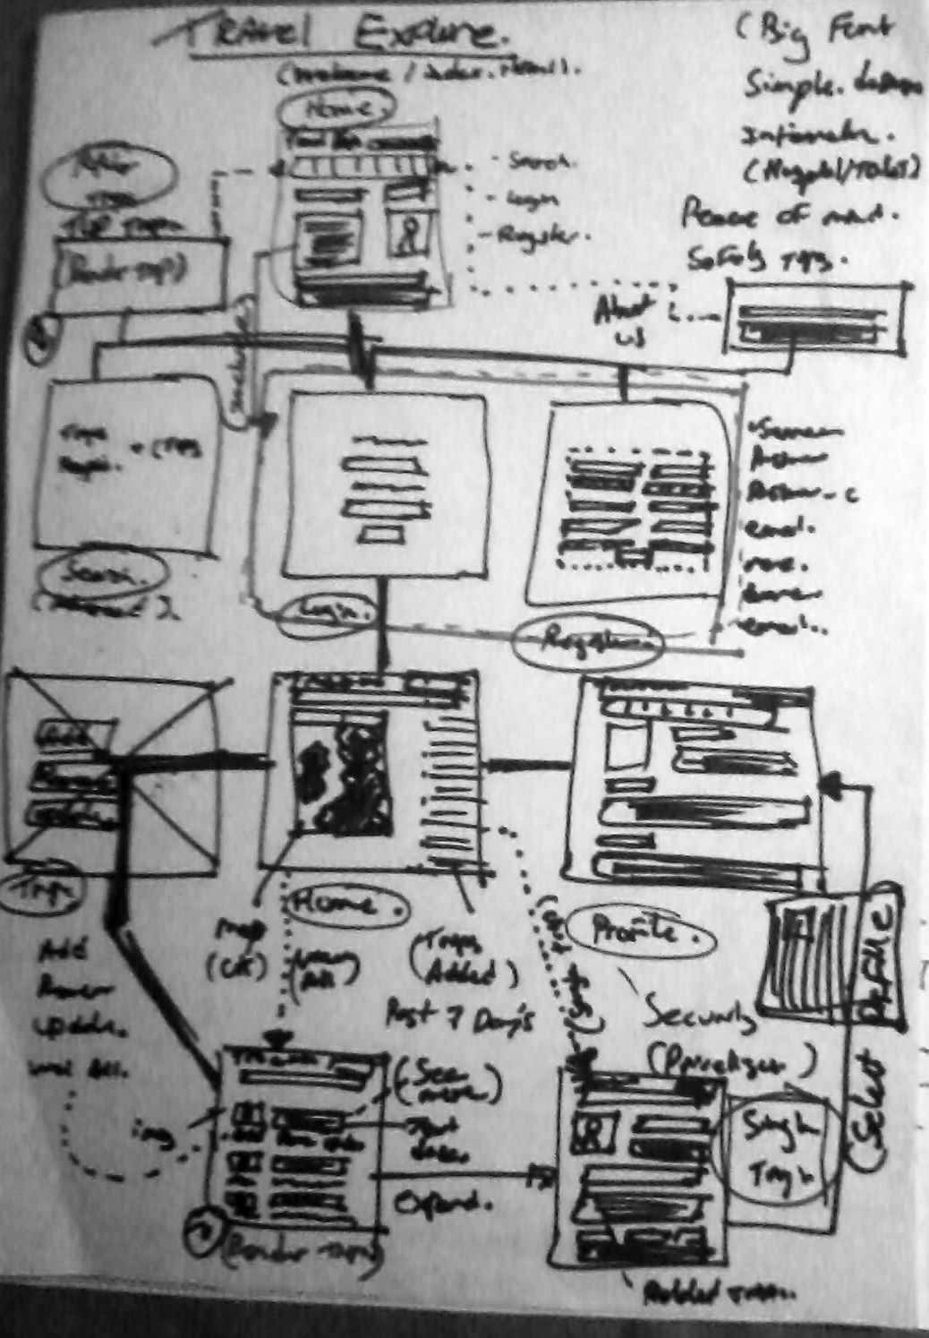

asdasd

We plan to progress to higher fidelity testing by producing electronic copies with a aesthetic akin to a rough sketch followed by a wireframe model. Ensuring a participant feels open to criticise the systems is vital in addressing key issues with the design to promote usability. At all times we will focus on visually representing the design as easily changeable and encouraging participants with positive feedback and making dynamic changes to the design to suit the individuals needs. We expect a small number of participants to test the system so on a small scale this is feasible to understand how a user interact with the system and make changes whilst it is still relatively inexpensive in terms of time available for the project.

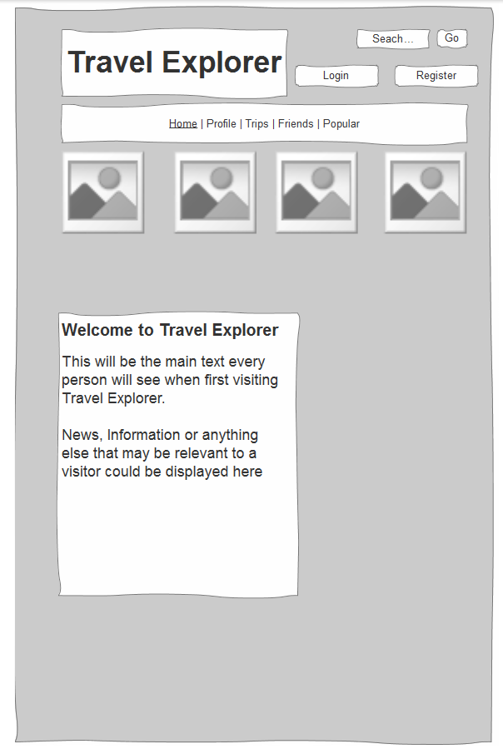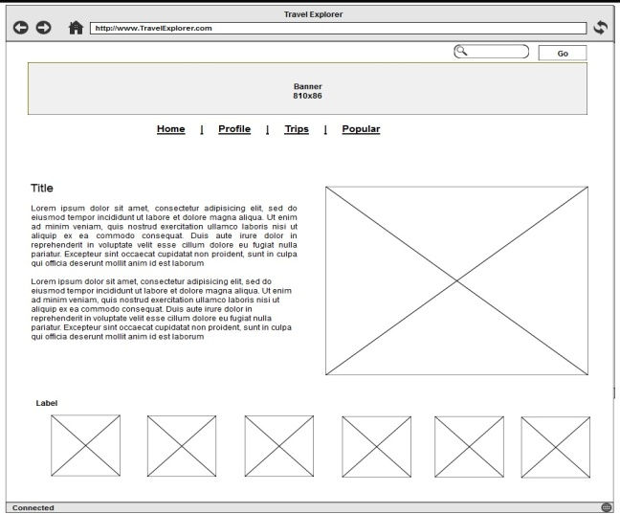

w3. (2007). *Optimal Colors to Improve Readability for People with Dyslexia.* Available: http://www.w3.org/WAI/RD/2012/text-customization/r11. Last accessed 28th Febuary 2013.

# Presentation Feedback

#### What type of devices did we plan to support?

The findings from the survey and from our discussion within the user centre clearly identified that although iPad’s and tablet devices were popular most elderly participants had received laptops and computers handed down from family members that were often old and out dated. Very few had access to iPads although most wanted access. To quote a user speaking about the advances in technology and why she was learning to use computers at the user centre, she said “I want to learn so I don’t get left behind”.

It is clear from our findings that elderly individuals do want to learn however they don’t always have the access to the newest or most up to date hardware which will be reflected in the requirements and the type of devices we develop for.

#### How did we plan to deal with security of information?

Security issues raised during the focus group, and discussed during the presentation can be divided into two sections. The security and personal safety of travellers while on a trip (Issues of local crime, places to avoid etc). The second is the data of travellers stored in the database and how this is kept and to whom access is granted.

We have contacted local police authorities, and travel agencies to receive information to help alleviate these concerns of personal safety. User groups, encrypted data, including password encryption and privacy options will be implemented by default to ensure that users will be able to control whom is given access to personal data. Options such as public, private or share amongst specific users or friends will allow users to control this. The ability to include safety information in the web application from other travellers was well received as this information would be hard to come across for people booking or going on a trip or holiday.

## Appendix

### Internet Survey Findings

* Two out of five (40%) adults age 50 and over consider themselves extremely (17%) or very (23%) comfortable using the Internet.
* The majority of those 50+ who access the Internet do so from a desktop computer (57%). One-quarter use a laptop (26%), 4 percent use smart phones/blackberries, 4 percent use mobile phones, and one-quarter (27%) do not access the Internet.
* Most respondents had heard of the Apple iPad (83%) and a small percentage of these respondents already own one (2%). Another one-tenth of those aware plan on or want to purchase an iPad (11%).

aarp. (2010). *Social Media and Technology Us e Among Adults 50+ (AARP 2010) Social Media and Technology Use Among Adults 50+.* Available: http://assets.aarp.org/rgcenter/general/socmedia.pdf. Last accessed 27th Febuary 2013.



